**DIGITAL MULTIMEDIA**

**PROJECT REPORT**

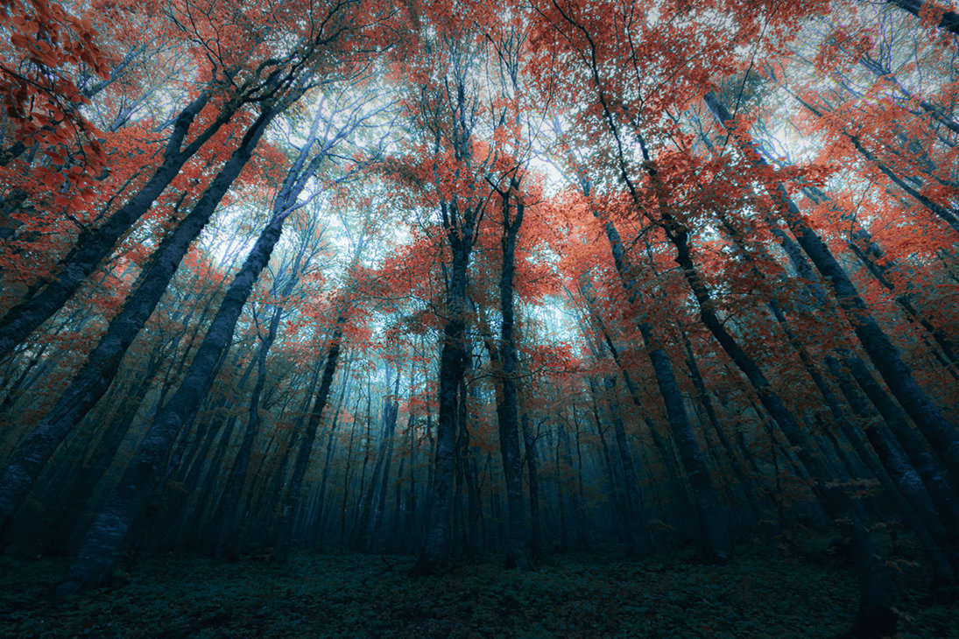

Love Hidden in the Leaves

|  |  |
| --- | --- |
| **PROJECT TEAM** | |
| **Student No** | **Student Name** |
| **X17347773** | **Tijesu Olalekan** |
| **X17342373** | **Abraham Marcus Alabi** |
| **X17366481** | **Christopher Angbalu** |
| **X17515503** | **Anthony Dempsey** |

Content

Contents

2. RESEARCH 2

3. SCRIPT 3

4. STORYBOARD 5

1. Overview

Our Project idea is online animation video that resolves around a love triangle between two best friends over a woman. The video will focus around the

# RESEARCH

** The research report should investigate **a minimum of 3** similar productions. Your findings should include any relevant details of the similar projects, such as what the competing project is, why you chose this project to research, how it is different/similar from your project idea, etc. This should also include your team’s reflection on each competing production, saying what you liked/disliked and whether anything inspired your own project. **

**NOTE:** Don’t forget to reference any third-party material at the end of the document!

# SCRIPT

** Include script for your project here, include as much information and detail into your script as you feel necessary. **

Scene 1:

* Clementine is in her house, in the kitchen when she heard loud knocks on her door. The knocks kept getting louder until she heard a voice.
* She opens the door & Elijah appears.

Scene 2:

* Clementine and Elijah are having discussion about a business opportunity.
* Before Elijah leaves , at the top of the stairs, clementine and Elijah hugs and as Elijah moves back and clementine kisses him
* As soon as Elijah pushes away, Nathaniel is watching in shock at the bottom of the stairs.
* With rage, Nathaniel runs & grabs Elijah and begins to attack him, while Elijah is trying to calm him down.
* Elijah had enough & decide to push back, while clementine is dragging Nathaniel to stop.
* Nathaniel trips himself, falls head first down the stairs dying instantly.
* Elijah & Clementine in shock run downstairs.
* Tears dripping for Elijah’s face as he begs Nathaniel to please wake up but with no success.
* Clementine who is also crying explains to Elijah that they have to move body.

Scene 3:

* The body of Nathaniel is in the trunk of the car.
* Elijah and Clementine are driving with incredible speed.

Scene 4:

* Elijah is burying the body of Nathaniel in a forest while Clementine is keeping watch.

Scene 5:

* The next morning, a man is walking his dog through the forest.
* The dog catches the scent of Nathaniel’s cologne and begins to trace it.
* The Dog stops and begins to howl.
* The owner begins to walk towards the dog’s location.
* Leaves are falling.

Scene 6:

* TO BE CONTIUNED!

# STORYBOARD

Story:

Love triangle between Elijah Nathaniel and clementine.

Clementine is in love with Elijah, but Nathaniel has been in love with clementine for time.

Elijah is Nathaniel best friend who soon kills Nathaniel in a heated argument which

Elijah raps the body up put in his 4by 4.

They hide the body in the forest, but clementine drops he pink glove at the burial site

A dog-walker his dog of the leash and the dog follows the scent of the blood from the body and the dog walker follows after finding the glove and the dog start digging to be continued…

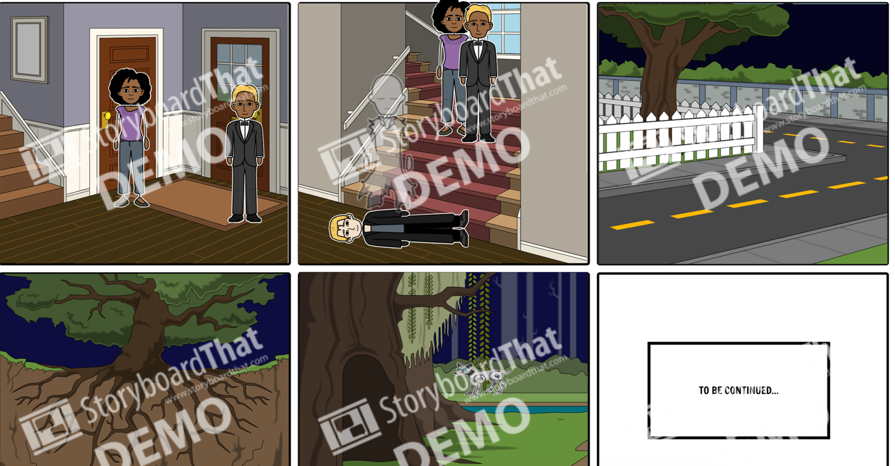

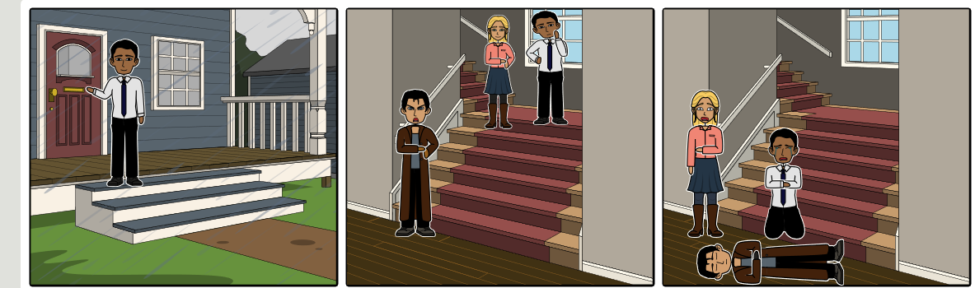

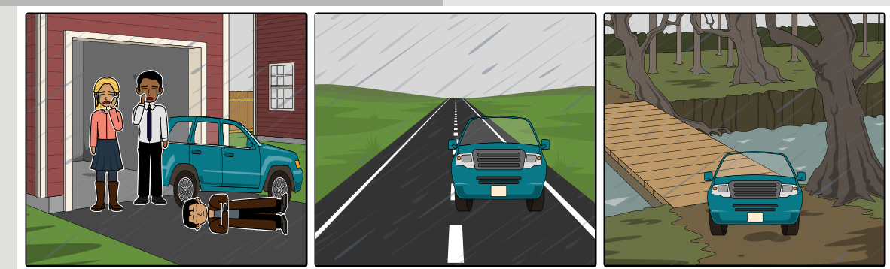

# TECHNICAL REPORT

** This section should outline what your initial project concept was and how you went about developing it into the final production. This should include all relevant development details, such as which methods you chose, i.e. video/animation/etc. and how you produced them, e.g. image editing process, animation development, video production, etc. You should also outline any technical details, such as errors or development issues. **

# PROJECT TEAM

** How did the project team break up the tasks required? Who did what tasks? Did everyone evenly participate? Were there any team issues? Etc. **

**PLEASE NOTE:** You will also be asked to peer review your team mates after submission

This section will outline what each member of the group has contributed to the project and what roles where given to members of the team. Our team came in during our 3 times a week during our Easter break to brainstorm ideas and communicate with each other. Everyone in the group had an input into what topic we would do and everybody took ideas into consideration when deciding how we were going to implement the animation.

|  |  |
| --- | --- |
| Name | ROLES |
| Anthony | * Editing * Researcher |
| Christopher | * Editing * Agenda Writer |
| TJ | * Storyboard * Editing |
| Marcus | * Scriptwriting * Editing |

1. **CONCLUSION**

** AFTER COMPLETION, looking back, how did the project go? Did you achieve what you set out to do? Are you happy with the results? Is there anything you might change if you had more time? Etc. **\*\***

**\*\*\*\*\*\*\*\*\*\*\*\*\*\*\*\*\*\*\*\*\*\*\*\*\*\*\*\*\*\*\*\*\*\*\*\*\*\*\*\*\*\*\*\*\*\*\*\*\*\*\*\*\*\*\*\*\*\*\*\*\*\*\*\*\*\*\*\*\*\*\*\*\*\*\*\*\*\*\*\*\*\***

You might like the photo on the cover page as much as we do, but if it’s not ideal for your report, it’s easy to replace it with your own.

Just delete the placeholder picture. Then, on the Insert tab, click Picture to select one from your files.